Open source vs. closed source software

Almost every piece of computer software is created using **source code**, which is the technical blueprint that tells a program how to function. When creators release their finished product to the public, they must decide whether to make its code open source or closed source.

***What is open source and closed source?***

**Open source software** is that by which the **source** code or the **base** code is usually available for modification or enhancement by anyone for reusability and accessibility. **Open source** code is the part of **software** that mostly users don't ever see.

**Examples of open source programs**

* Linux operating system.
* Android by Google.
* Open office.
* **Firefox** browser.
* VCL media player.
* Moodle.
* ClamWinantivirus.
* WordPress content management system.

With **closed source software** (also known as proprietary software), the public is not given access to the source code, so they can’t see or modify it in any way.

On mobile and tablet systems, **closed**-**source operating** systems include Windows Phone, iOS and the Symbian **OS** that is used by BlackBerry. **Android** is based on the open-**source** Linux **OS**, though it has many proprietary, **closed**-**source** extensions.

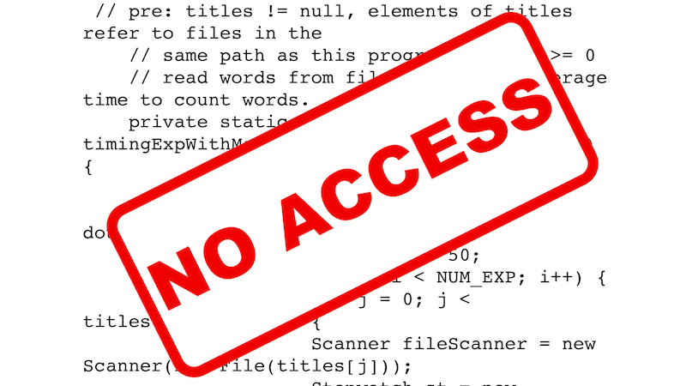

|  |  |
| --- | --- |
| **Closed-Source Software** | |
| **Skype** | Peer-to-peer Voice over Internet Protocol (VOIP) software |
| **Adobe Flash** | Manipulate vector and raster graphics / streaming of audio and video |
| Google Earth | View satellite imagery, maps, terrain, 3D buildings |

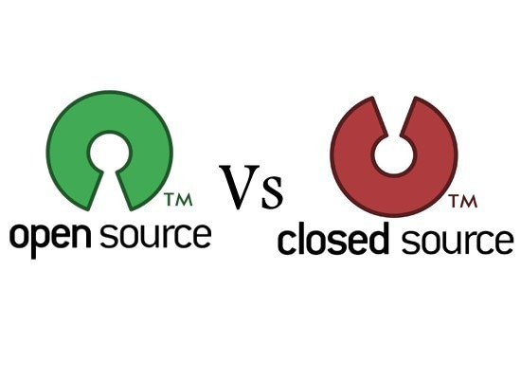

But with **open source software**, the source code is publicly available to anyone who wants it, and programmers can read or change that code if they desire. Keep in mind that you don’t have to read or modify any code in order to use an open source product.

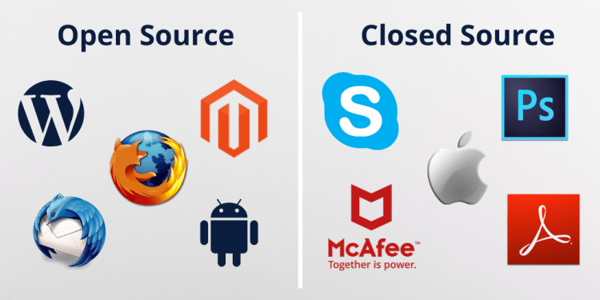

**Android** is an **open source** operating system for mobile devices and a corresponding **open source** project led by **Google**. ... As an **open source** project, **Android's** goal is to avoid any central point of failure in which one industry player can restrict or control the innovations of any other player.

Google's **Android** is considered an Open **Source** mobile OS, while **Apple's** iOS is considered **closed source** and each has its own benefits and issues. ... By having an Open **Source** software program, you allow developers to alter large amounts of the code to their own preference.

**Python** is developed under an OSI-approved **open source** license, making it freely usable and distributable, even for commercial use. **Python's** license is administered by the **Python** Software Foundation.



**Microsoft Windows**, a closed-**source**, operating system, has come under pressure from Linux, an **open source** one. Similarly, **Microsoft** Office, a closed- **source**, office productivity suite, has been under fire from OpenOffice, an **open source** one (which is the foundation for Sun's StarOffice).

Any Software whose **source** is not available in a public domain is called **Closed Source** Software. 80% of the softwares you use on Windows will probably be **closed source** softwares. Ex: MS Office, Internet Explorer, Notepad, Paint, Adobe **Photoshop**,Skype,Windows Media Player... All are **Closed Source** only.

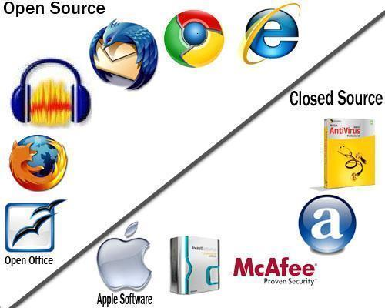

– Cost: **Open source** software tends to be free, so it's usually the best choice for individual users. **Closed source** can cost more, as it has to be designed for the user's needs.

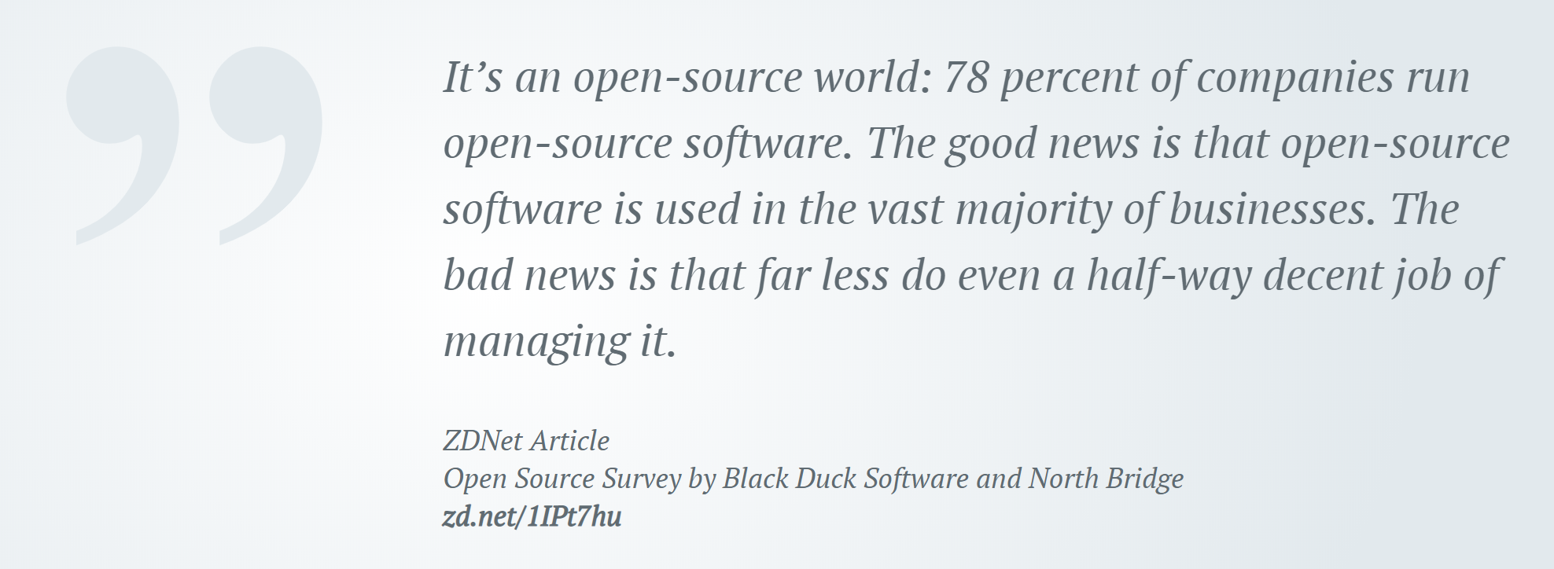

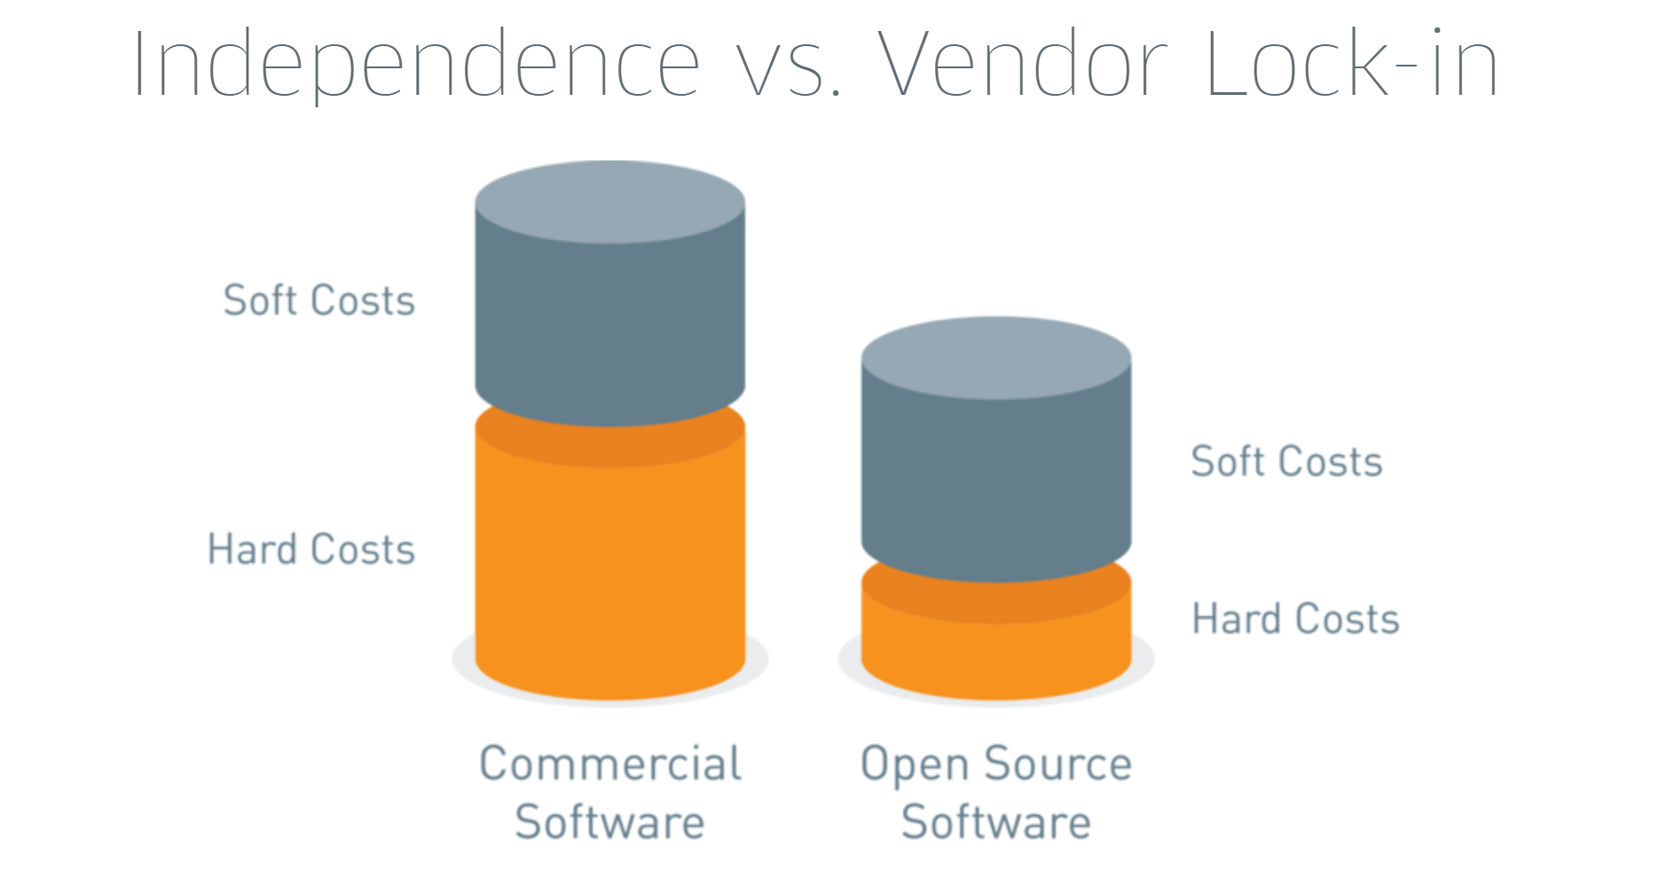

– Service: **Closed source** software is the winner here, as there are usually dedicated service teams that can help you when things go wrong.



*Open source software and closed source software have different features in terms of maintenance, service and expense. Due to, open source software’s accessibility and cost, it is preferred by users. Otherwise, close source software is favored by corporations since it matches with their working model.*